1.0 OBJECTIVE

It is a strategic objective of corporate nuclear fuels and all on-site departments to operate with zero fuel defects. Although zero fuel defects is the goal, this goal is not intended to imply that the reactor cannot be operated with minor indications of defective fuel.

This procedure establishes the requirements and organizational responsibilities associated with the prevention, detection, and categorization of, and response to, indicated fuel failure during normal plant operation.

TABLE OF CONTENTS

Section Page

2.0 APPLICABILITY . . . . . . . . . . . . . . . . . . . . . . . . . . . . . . . . . . . . . . . . . . . . . . . . . . . . . . . . . 2

3.0 REFERENCES . . . . . . . . . . . . . . . . . . . . . . . . . . . . . . . . . . . . . . . . . . . . . . . . . . . . . . . . . 2

4.0 RESPONSIBILITIES . . . . . . . . . . . . . . . . . . . . . . . . . . . . . . . . . . . . . . . . . . . . . . . . . . . . . . 2

5.0 REQUIREMENTS . . . . . . . . . . . . . . . . . . . . . . . . . . . . . . . . . . . . . . . . . . . . . . . . . . . . . . . . 5

6.0 PRECAUTIONS/LIMITATIONS . . . . . . . . . . . . . . . . . . . . . . . . . . . . . . . . . . . . . . . . . . . . . 6

7.0 PREREQUISITES . . . . . . . . . . . . . . . . . . . . . . . . . . . . . . . . . . . . . . . . . . . . . . . . . . . . . . . . 6

8.0 PROCEDURE . . . . . . . . . . . . . . . . . . . . . . . . . . . . . . . . . . . . . . . . . . . . . . . . . . . . . . . . . . . 6

Attachments

1 FAILED FUEL ABSTRACT . . . . . . . . . . . . . . . . . . . . . . . . . . . . . . . . . . . . . . . . . . . . . . . . 15

2 REFERENCES . . . . . . . . . . . . . . . . . . . . . . . . . . . . . . . . . . . . . . . . . . . . . . . . . . . . . . . . . 18

3 DEFINITIONS . . . . . . . . . . . . . . . . . . . . . . . . . . . . . . . . . . . . . . . . . . . . . . . . . . . . . . . . . . 19

.

2.0 APPLICABILITY

This procedure applies:

2.1 During normal operation to detect fuel failures

2.2 When failed fuel is indicated during normal plant operation

This procedure DOES NOT apply to gross fuel failures caused by severe reactor transients/accidents

3.0 REFERENCES

See Attachment 2.

4.0 RESPONSIBILITIES

4.1 VICE PRESIDENT NUCLEAR PLANT SITE

The Vice President Nuclear Plant Site is responsible for:

4.1.1 Ensuring that an effective fuel integrity monitoring program is established at the plant site, the fuel vendor operational recommendations are implemented and followed, and the results are used to minimize fuel failures and radiation exposure.

4.1.2 Ensuring that all plant personnel are aware of the importance of fuel reliability and ensure that evaluations of all plant design changes, operating changes, and maintenance activities include an assessment of any possible impact on fuel integrity.

4.1.3 Ensuring that plant procedures and operating strategies are in accordance with the established operating recommendations set forth by this procedure IF fuel cladding failure occurs.

4.1.4 Adjusting the Administrative Off-gas Limit (AOL), when necessary, to account for changes in system leak rates, HVAC performance, maintenance or refueling activities or for other reasons.

4.2 ENGINEERING SUPPORT DEPARTMENT

The Reactor Engineering group under the direction of the Engineering Support Manager is responsible for:

4.2.1 Supporting the SNC Fuel Performance Engineer in the implementation of an effective fuel integrity monitoring program. This support includes:
4.2.1.1 Evaluation of reactor core operational parameters that are pertinent to fuel conditions, as requested.

4.2.1.2 Investigative activities of identified abnormal or anomalous trends and/or data, as necessary.

4.2.1.3 Ensuring that plant radiochemistry and core operational data are supplied in a timely manner.

4.2.2 Making recommendations to the plant management staff on core operational strategies to minimize the plant-wide effects of fuel failures.

4.2.3 Ensuring that Reactor Engineering core management policies are established which minimize the potential for fuel failures and the effects of leaking fuel.

4.2.4 Providing engineering oversight for new fuel inspection and ensuring that the Project Fuel Coordinator and the Nuclear Fuels Department are informed of any deviations found during new fuel inspection activities.

4.2.5 Providing engineering oversight for non-routine activities such as local power suppression testing OR fuel inspection and/or reconstitution activities as required by this procedure, and assisting the corporate and vendor technical groups in the data analysis and evaluation.

4.2.6 Where possible, ensuring that failed, damaged or otherwise defective fuel bundles are segregated in a designated defective fuel rack in the Spent Fuel Pool.

4.3 OPERATIONS DEPARTMENT

The Operations Department under the direction of the Operations Manager is responsible for:

4.3.1 Establishing operational policies and procedures consistent with fuel operating recommendations in an effort to minimize the potential for fuel failures and their effects.

4.3.2 Ensuring that core operational activities and recommendations of plant groups (e.g., Shift Technical Advisor, Reactor Engineering) are consistent with other operating considerations.

4.3.3 Ensuring that the Operations staff is properly trained in fuel handling methods, procedures, and equipment.

4.3.4 Implementing corrective action (e.g., derate power levels, ramp rate restrictions) as required by this procedure and in accordance with other operating considerations.
4.3.5 Shift Technical Advisor Group is responsible for:

4.3.5.1 Providing technical guidance to members of the Operations staff on-shift concerning fuel reliability matters.

4.3.5.2 Providing technical guidance and assistance in implementing corrective actions as required by this procedure in the event of fuel failures.

4.3.5.3 Ensuring that the site Reactor Engineering Group is kept abreast of all operational activities and system events that could affect fuel performance such as:

4.3.5.3.1 Ramp rates in excess of operating recommendations (IF applicable)

4.3.5.3.2 Excessive cooldown/heatup rates and/or reactor transients

4.3.5.3.3 Unusual control rod movements and configurations

4.3.5.3.4 Abnormal increases in offgas pretreatment activity.

4.4 CHEMISTRY DEPARTMENT

The plant Chemistry group under the direction of the Health Physics and Chemistry Manager is responsible for the following:

4.4.1 Collecting radiochemistry and water chemistry data pertinent to fuel performance.

4.4.2 Ensuring that existing chemistry policies and procedures are consistent with this procedure in the event of fuel failures.

4.4.3 Ensuring that plant procedures are in place to dictate the use and handling methods for substances which may be hazardous to the fuel cladding IF allowed to enter the reactor water system.

4.4.4 Reporting abnormal, out of specification, or substantial changes in reactor water chemistry and radiochemical parameters to Plant Management and the Reactor Engineering Supervisor.

4.4.5 Systematic monitoring, trending and evaluation of radiochemistry and reactor coolant data to identify abnormal trends and/or data that is detrimental to fuel cladding performance or indicative of a failed fuel condition.

4.4.6 Responding to special chemistry data collection requests as required by this procedure.

4.4.7 Performing calibration tests and other activities as necessary to ensure accurate offgas flow measurement.

4.5 MAINTENANCE DEPARTMENT and WORK CONTROLS DEPARTMENTS

The Maintenance and the Work Controls Departments are responsible for the following:

4.5.1 Ensuring plant procedures are in place which include guidance on maintaining cleanliness of those systems or areas that could introduce foreign material into the reactor core or spent fuel pools during maintenance, refueling, and modification activities.

4.5.2 The Refueling Floor group under the direction of the Maintenance Manager is responsible for the following:

4.5.2.1 Performing fuel sipping to identify leaking fuel bundles.

4.5.2.2 Ensuring that appropriate controls are in place to minimize the chance for entry of debris into fuel bundles during fuel handling and receipt inspection and during fuel pool cleanup work.

4.6 OFFSITE SUPPORT

The primary parties involved are the Hatch Project Fuels Coordinator and the Nuclear Fuels Department.

The Fuel Performance Engineer (Nuclear Fuels Department) will be responsible for monitoring and trending fuel performance data as outlined in Reference 5 on Attachment 2.

5.0 REQUIREMENTS

N/A - Not applicable to this procedure

5.1 PERSONNEL REQUIREMENTS

N/A - Not applicable to this procedure

5.2 MATERIAL AND EQUIPMENT

N/A - Not applicable to this procedure

5.3 SPECIAL REQUIREMENTS

Actions for the different Action Levels may be performed in other than the order written and actions for higher Action Levels may be utilized to augment the response of lower Action Levels as recommended by plant/off-site groups.

6.0 PRECAUTIONS/LIMITATIONS

N/A - Not applicable to this procedure

7.0 PREREQUISITES

N/A - Not applicable to this procedure

8.0 PROCEDURE

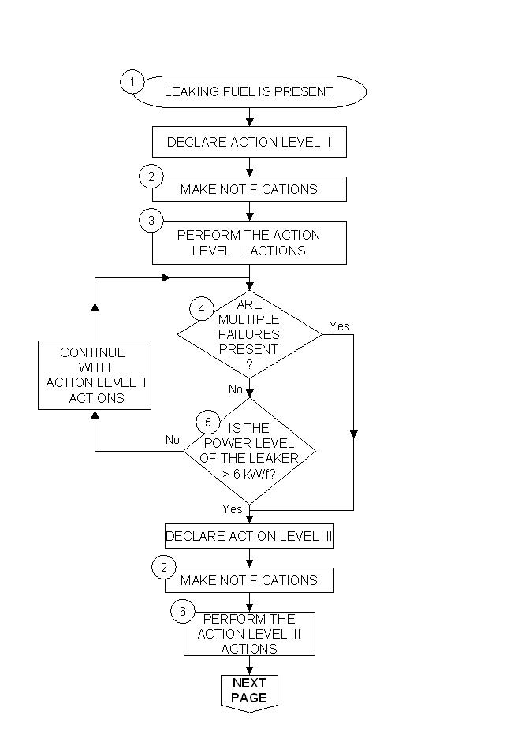
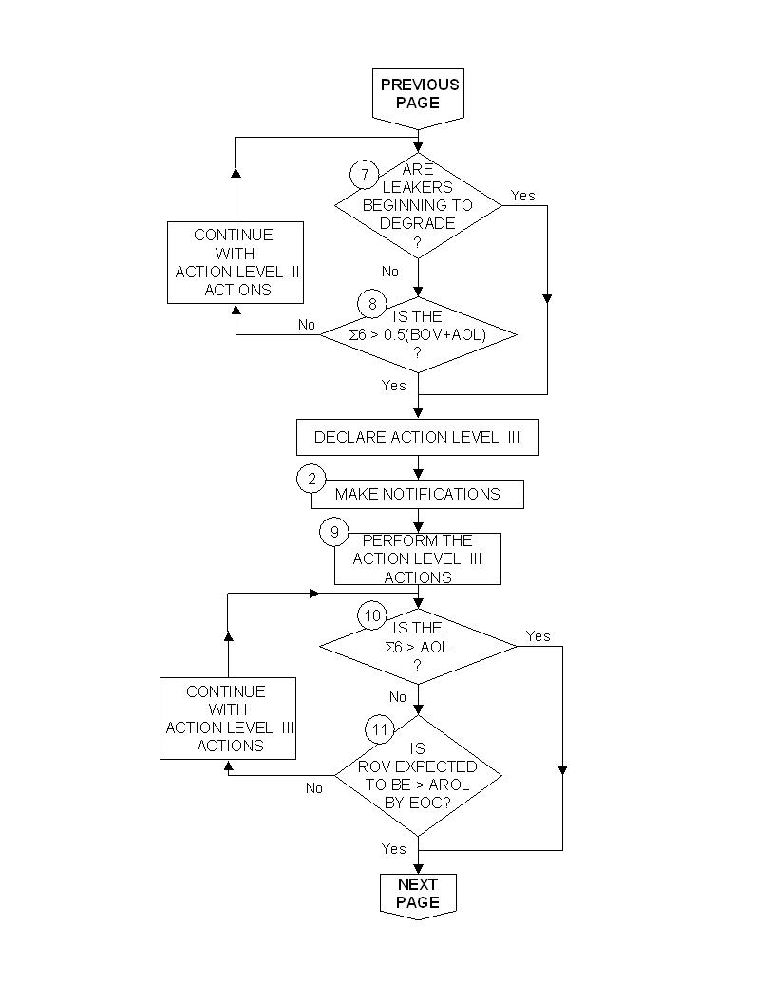
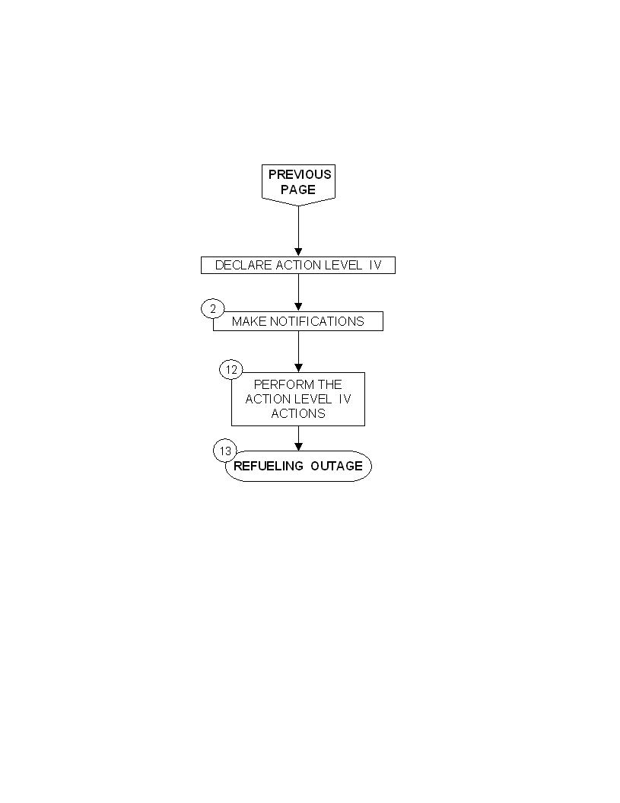

LEAKING FUEL IS PRESENT  1 | Fuel failures are suspected due to an increase in pretreatment  Radiation monitor readings and sum-of-the-six off-gas levels from normal levels OR a change in key parameter ratios (e.g., Xe-133/Σ6) as detected during routine monitoring.
2  MAKE NOTIFICATIONS | The Reactor Engineering Group WILL notify:  • The Vice President Nuclear Plant Site OR his designee,  • The SNC Nuclear Fuels Department,  • The Chemistry Department.
3  PERFORM THE ACTION  LEVEL I ACTIONS | Reactor Engineering WILL:  • Collect radiochemistry, off-gas, and plant operating data as  needed by the Nuclear Fuels Department,  • Make recommendations to Operations on operating strategy  (such as ramp rate restrictions),  • Advise Outages & Modifications for scheduling of fuel sipping  and irradiated fuel inspection during the next refueling outage.  Chemistry (as per Reactor Engineering recommendations) WILL:  • Increase monitoring/sampling to at least twice per week,  • Perform Cesium sampling and analysis after any large power  change and after transients.  SNC Nuclear Fuels Department WILL:  • Assess the data to determine benefit/effectiveness of the oper-  ational strategies in mitigating the consequences of the leaker,  • Develop plans for sipping/end-of-cycle sipping and irradiated  fuel inspection,  • Request a review of fabrication and other design records by  the fuel vendor. Fuel assemblies and components that may  be marginally within acceptable specifications will be brought to  the attention of SNC management.
ARE  MULTIPLE  FAILURES  PRESENT  ?  4 | Analysis of off-gas data indicates that  more than one fuel failure  is present

IS THE  POWER LEVEL  OF THE LEAKER  > 6 kW/f?  5 | This condition is characterized by a Xe-133 release rate of  greater than approximately 10 μCi/s above the current  recoil level of Xe-133.
6  PERFORM THE ACTION  LEVEL II ACTIONS | In addition to the actions specified for Action Level I  Plant Management WILL consider the cessation of any special water  chemistry programs.  Reactor Engineering WILL:  • As necessary, perform Flux Tilt Testing in an effort to determine  the core location of the fuel failure,  • In an effort to minimize the impact of the fuel failure on cur-  rent cycle operation, end-of-cycle plant maintenance and  expected outage dose rates recommend some or all of the  following changes in core operational strategies:  1. Core wide OR local power limitations for control rod  movements,  2. Perform control rod sequence exchanges and scram  time testing at power levels reduced from normal,  3. Impose ramp rate restrictions on certain fuel batches  depending upon the estimated severity of the failure  and the expected effect on plant capacity factor.  Chemistry (as per Reactor Engineering recommendations) WILL:  • Increase the present monitoring/sampling rate to help estab-  lish a defined reference database and/or trends which show  degradation,  • IF necessary, perform Neptunium sampling and analysis.  SNC Nuclear Fuels Department WILL:  • Utilize the estimated number of leakers and their location for  end-of-cycle planning,  • Assess the impact of failed fuel on future reload cycle designs  and the impact of prolonged operation with high activity on  plant operation and maintenance,  • Coordinate with site Reactor Engineering Group to provide  management a summary of the fuel situation, probable  causes, and end-of-cycle fuel examination/reconstitution  planning activities.

ARE  LEAKERS  BEGINNING TO  DEGRADE  ?  7 | At this juncture the fuel failure has become severely degraded  OR  a secondary failure has occurred within the fuel pin permitting  Uranium to escape into the coolant where it can deposit on  incore surfaces.
IS THE  Σ6>0.5(BOV+AOL)  ?  8 | At this level, the off-gas release directly from leaking fuel rods has become relatively high. The off-gas from the leaking fuel plus the additional tramp Uranium fissioning has increased to more than one half of the AOL above the BOV

9  PERFORM THE ACTION  LEVEL III ACTIONS | In addition to the actions specified for Action Level I and Level II  Plant Management will need to consider the effect of fission product activity  on planned plant maintenance and other site activities during the upcoming  outage and may need to consider the possibility of advancing the next  scheduled outage to accommodate the removal of the failed fuel.  Reactor Engineering WILL:  • In an effort to minimize the impact of the fuel failure on cur-  rent cycle operation, end-of-cycle plant maintenance and  expected outage dose rates, and to reduce the potential of  creating new defects. Recommend some or all of the following  changes in core operational strategies:  1. Implement those operating changes which were listed under  Action Level II responses that are not already implemented.  2. Implement a core power derate of 15% or 30% depending on  the failure mechanism (a derate is more beneficial if  successive fuel failures due to CILC or a similar mechanism  are believed to be occurring,  3. Alter the control rod pattern as appropriate to reduce local  power levels in the vicinity of the leaking fuel rods.  SNC Nuclear Fuels Department WILL:  • Review the impact on core licensing analysis and assess the  impact on future core designs before exceeding 137 critical days in  one control rod sequence OR before deviating significantly from the  operating plan of the current Cycle Management Report,  • Review and modify as necessary plans for sipping, failure  examination/investigation, and replacement and/or reconstitution  activities at the end-of-cycle refueling outage.
IS THE  Σ6 > AOL  ?  10 | The off-gas from the leaking fuel plus the additional tramp Uranium  fissioning has exceed the AOL

IS  ROV EXPECTED  TO BE > AROL  BY EOC?  11 | One or more of the leakers has begun to degrade permitting Uranium to escape into the coolant where it can deposit on incore surfaces, AND the ROV due to the degradation is expected to reach the AROL before the scheduled EOC.
12  PERFORM THE ACTION  LEVEL IV ACTIONS | In addition to the actions specified for Action Level I, II, and III  Since a power derate has the benefit of both slowing the progression of the failures and reducing off-gas generation and release through existing defects, further power reduction may be advised depending on the failure mechanism.  Depending on the severity, an unscheduled outage to remove the failed fuel may need to be considered.  Consider consulting industry resources to provide technical review and assistance.
REFUELING OUTAGE  13 | The termination point for the failed fuel action plan is the removal of the failed fuel from the vessel. During the refueling outage, every reasonable effort will be made through sipping, fuel inspection, and reconstitution to ensure failed, suspect, and susceptible fuel assemblies are identified and NOT reinserted into the core thereby ensuring reliable fuel performance during the next cycle. IF debris-related failures have occurred OR if debris is found in the fuel, a statistically sound fuel inspection plan will be developed.  The SNC Nuclear Fuels Department will ensure fuel inspection is conducted with a level of detail which provides assurance that the root cause(s) of the fuel failures are clearly understood and that remedial actions are well delineated to prevent gross fuel failure from occurring in subsequent operating cycles.  The SNC Nuclear Fuels Department, in coordination with the site Reactor Engineering group, will provide management with a detailed summary implemented to prevent recurrence of fuel failures in subsequent operating cycles.  In addition, IF fuel failure investigations indicate that the failure mechanism is generic in nature, THEN the corporate staff will ensure other utilities and industry groups, as appropriate, are informed in an effort to minimize their risk of experiencing similar fuel failures.

FAILED FUEL ABSTRACT

Typically, failure mechanisms are manufacturing defects, Pellet Clad Interaction (PCI) failures, and debris/fretting failures. Until recently, most instances of these failure types in BWRs have not significantly affected plant operation. When these failures occur, there are generally three or fewer failures in any cycle. The off-gas level increase associated with this type of failure usually exhibits one or two discrete step increases.

Early fuel failures were due to stress corrosion cracking. Rapid power increases would cause faster thermal expansion of the fuel pellets than the fuel cladding. This produced high stresses on the fuel cladding leading to cladding failures. And certain fuel types were relatively more susceptible to post-defect degradation than others. GE’s initial recommendation to prevent this type of failure, until a permanent solution could be developed, was the implementation of the Pre-Conditioning Interim Operating Management Recommendations (PCIOMR). PCIOMR would prevent these types of failures by increasing power only in slow controlled power ramps (i.e. 10 MWe/Hr).

The final solution to these early fuel failures was the design of barrier fuel cladding. This new cladding allowed for a return to rapid power increases with little fear of fuel failures. While the pellet - clad interaction type of fuel failures have decreased due to barrier fuel, fuel failures have continued for various other reasons.

With barrier fuel, after the initial fuel failure, severe cladding degradation can occur for some rods. There are two possible mechanisms of cladding degradation. If the initial fuel failure is a sharp, longitudinal crack, then the split can be extended by a power ramp. This longitudinal crack is the likely result of stresses on flaws on the cladding wall during fabrication. The second type of degradation results from water entering the original fuel pin failure and thus forming a steam blanket on the inside of the fuel pin. At a location remote from the primary defect, massive hydriding occurs due to oxygen starvation. A power ramp on the hydride-damaged region of the pin can also result in a cladding failure.

In either case, the trigger for the degradation is the power ramp. It is believed that the reason for the longitudinal failure being rare in non-barrier fuel was due to the limited ramp rates imposed on operations due to PCIOMR operating strategies.

The fuel vendor has recommended that once the location for a fuel failure has been determined, the control rod for that fuel cell be fully inserted to limit the local power around the failed fuel rod(s).

Increases in the tramp activity can occur when axial cracks or other secondary defects occur in the cladding of leaking rods. When the coolant is exposed directly to the fuel pellets, pellet washout occurs. Fissile material will gradually erode and become entrained in the coolant. A portion of the fuel particles will deposit on incore surfaces causing increases in background for the current and later cycles. If no
cracks or large secondary defects occur in the leaking rod(s), relatively little fissile material will erode and plant noble gas releases will remain stable.

If the power of the leaking fuel rod(s) is reduced by the insertion of control rod blades close to the leaker(s), then the potential for clad cracking and subsequent pellet washout is reduced. Therefore, it is desirable to perform a power suppression test and control blade insertion as soon as feasible after detection of new leaking fuel pins.

The break point of 6 kW/ft between Action Levels 1 and 2, defined as approximately 10 µCi/s above the current recoil level of Xe-133, is chosen because it is difficult or impossible to detect a leaking fuel rod operating at less than about 6 kW/ft, especially if there is significant tramp uranium present. The Xe-133 release from rods operating at lower power levels is difficult to distinguish from background.

The first criterion in determining Action Level II is that there is more than one leaker present or that the leaking fuel is operating at a high power level. The second criterion for Action Level II can be met even if the sum-of-six is relatively low, provided that degradation has started and has progressed long enough to permit a projection. (The rate of increase in the ROV is relatively constant and predictable, once degradation starts. Operational changes have little impact on the ROV trend, based on industry experience.) Degradation is characterized by steady, increasing values of the ROV without accompanying increases in the non-recoil offgas and by increasing levels of Np-239, Sr-91 and Sr-92. The increase in the ROV may or may not be accompanied by increases in the non-recoil offgas release rates.

Increases in the non-recoil off-gas level to greater than 10,000 µCi/sec can be due to formation of secondary fuel failures. Such failures occur on fuel rods with existing primary failures that may be due to debris/fretting, PCI (Pellet-Clad Interaction), manufacturing defects, or any other cause. In general, secondary fuel failures result from a combination of fuel pellet swelling due to oxidation and cladding degradation due to hydriding. Under some conditions, very large cladding holes or splits can develop. Such failures may be accompanied by high off-gas levels, even when only one or two failed rods are present.

In most cases, it is possible to determine when large, secondary fuel failures have occurred. Analysis of off-gas isotopics will indicate that most of the increase in the off-gas results from increases in the recoil term. Short-lived noble gas isotopes such as Xe-138 will increase greatly, while long-lived isotopes such as Xe-133 will increase relatively little. When there are large off-gas increases, but the proportion of the recoil term remains fairly constant, it is likely that additional leaking fuel rods have developed.

In addition, the Project Fuel Coordinator/Nuclear Fuels Department will review the possibility of fuel reconstitution or the availability of replacement spent fuel assemblies or new fuel assemblies if reconstitution during the scheduled outage is not feasible. Implicit in the performance of this task is procurement efforts for tie plates, manpower scheduling and outage planning. An appropriate level of core design and licensing flexibility will be considered to accommodate likely fuel inspection results. A review of the fuel reliability goals during subsequent cycles and the cost-benefit for implementing irradiated fuel examination and/or reconstitution will be reviewed by the responsible groups.

If the increase in offgas is believed to be due to degradation of one or more leaking fuel rods, then a core power derate will probably be of little benefit in reducing the degradation rate. A derate is more beneficial if successive fuel failures due to CILC or a similar mechanism are believed to be occurring. A derate will reduce the recoil offgas and the sum-of-six approximately in linear proportion to the power level reduction; this may facilitate plant operation during the period while the derate is used. However, little long-term benefit can be expected from a core power derate in terms of the tramp release to the system.

In some cases, this may be inconsistent with normal core management practices developed to reduce fuel costs or increase fuel operating margins. In particular, next cycle core design may need to accommodate the discharge of a significant quantity of fuel from each batch that could reasonably be affected. Recommendations as to which fuel batches to reconstitute will be finalized based upon the feasibility study and the latest off-gas information. If Action Level IV is reached, it is indicative that none of the measures used at the less severe action levels to slow the fuel failures have been effective.

Depending upon the severity, an unscheduled outage to remove the failed fuel may need to be considered. Feasibility of an early shutdown would be contingent upon the other unit's status, time of year, availability of fresh fuel, and the impact a shutdown would have on the next cycle's operation. The magnitude of the recoil off-gas level as an indicator of significant cladding degradation also needs to be factored into the decision for early reactor core shutdown. The primary reason for this consideration is that residual recoil off-gas levels in the next cycle may be high enough to prevent full power operation even though all leaking fuel will have been discharged.

During the outage, every reasonable effort will be made through sipping, fuel inspection, and reconstitution (if necessary) to ensure failed, suspect, and susceptible fuel assemblies are identified and NOT reinserted into the core thereby ensuring reliable fuel performance during the next cycle. IF debris-related fuel failures have occurred OR if debris is found in the fuel, a statistically sound fuel inspection plan will be developed.

Per reference 5, the Project Fuel Coordinator/Nuclear Fuels Department should ensure fuel inspection is conducted with a level of detail which provides assurance that the root cause(s) of the fuel failures are clearly understood and that remedial actions are well delineated to prevent gross fuel failure from occurring in subsequent operating cycles.

Per reference 5, the Project Fuel Coordinator and Nuclear Fuels Department, in coordination with the site Reactor Engineering group, should provide management with a detailed summary implemented to prevent recurrence of fuel failures in subsequent operating cycles. In addition, IF fuel failure investigations indicate that the failure mechanism is generic in nature, THEN the corporate staff should ensure other utilities and industry groups, as appropriate, are informed in an effort to minimize their risk of experiencing similar fuel failures.

1. EPRI TR-100659, Final Report, Fuel Reliability Improvement Guidelines, April 1992

2. INPO SOER 90-02 "Nuclear Fuel Defects"

3. Final Safety Analysis Report, Unit 1, Section 3.2

4. Final Safety Analysis Report, Unit 2, Section 4.2.1

5. NFS 6-1, Fuel Integrity Monitoring and Analysis (corporate procedure)

6. INPO Good Practice TS-409, Fuel Integrity Monitoring, June 1986

7. NEDE-21493, PCIOMR Implementation Procedures, Rev. 5, February 1982

8. SIL 379, Rev. 1, Power Suppression Testing, July 16, 1993

9. SIL 552, Rev. 1, Fuel Failures Caused by Metal Debris, June 21, 1994

10. EPRI TR-102799, Interim Report, Severe Degradation of BWR Fuel Failures: Coolant Activity Analysis, November 1993

11. EPRI NP-5521-SR, Special Report, Failed Fuel Action Plan Guidelines, November 1987

12. NEDC-32290P, Failed Fuel Degradation, December 1993

13. EPRI TR-103655, Evaluation of High Off-Gas Failures in Barrier and Non-Barrier BWR Fuel, March 1994

14. NEDC-32711P, Post-Irradiation Evaluation of BWR Fuel from Hatch-2 Reactor, March 1997

15. EPRI TR-107887 DEFECT, Defective Fuel Element Code-T, August 1997

- NEDC-324070P, Failed Fuel Degradation Update, October 1994.

- INPO 07-004, Guidelines for Achieving Excellence in Nuclear Fuel Performance

- EPRI Fuel Integrity Monitoring and Failure Evaluation Handbook, Revision 1, November 2003, Section 6

The following terms and definitions pertain to offgas measurement and fuel failures:

Total Off-gas

Total noble gas release rate measured at the pretreatment monitors in µci/s.

Sum-of-the-Six (Σ6)

The sum-of-the-six refers to the sum of the pretreatment release rates for the following six isotopes: Xe-133, Xe-135, Xe-138, Kr-85m, Kr-87, Kr-88 and in µCi/s.

Baseline Offgas Value (BOV)

The average value of Σ6 measured at 100% power, steady-state conditions during the first month of the cycle with no leakers present. Alternatively, the BOV can be estimated using the Recoil Offgas Value (ROV) at the end of the previous cycle, multiplied by the fraction of the fuel from the previous cycle that is reinserted for the current cycle.

Administrative Off-gas Limit (AOL)

The administrative off-gas limit (AOL) refers to an administrative limit which is more conservative than those established for limiting off-site releases. Full power operation is allowed WHEN off-gas limits DO NOT exceed the AOL. The AOL also meets requirements for unit accessibility and personnel dose in areas of the plant affected by airborne activity WHEN fuel failures occur. The default AOL is generally taken to be 35,000 μCi/sec (sum-of-the-six) above the BOV. The AOL can be adjusted up or down by the Vice President to reflect actual airborne gas levels in the plant.

Recoil Offgas Value

The recoil offgas value (ROV) is the portion of the sum-of-the-six due to direct knockout of fission products from tramp uranium or fuel that is in direct contact with the coolant, corrected to full power conditions. When there are no leaking rods, or when all leaking rods have been suppressed in power, the ROV is approximately equal to the sum-of-the-six release rate. In other cases, the recoil offgas can be estimated by analysis of offgas data with the EPRI CHIRON code or a similar program. When operating at less than full power conditions, the ROV is determined by dividing the recoil level at the operating power level by the fraction of rated thermal power at that time. (Note that at beginning of cycle full power steady state conditions, with no leaking fuel, ROV = BOV.)

Administrative Recoil Offgas Limit (AROL)

The AROL is an administrative offgas limit which applies to the ROV. The AROL addresses the need to consider the level of offgas release that will occur during upcoming cycles, if those cycles have no leaking fuel. The recoil level of offgas is also closely related to the amount of fission products such as Sr-91, Sr-92, and Cs-137, and isotopes such as Np-239 present in reactor water and on primary coolant surfaces. High levels of these isotopes can affect personnel dose during outages. The default value of the AROL is 9,000 µCi/sec. The AROL can be adjusted up or down by the Vice President to reflect actual plant conditions.

Normal Operation

Normal operation occurs WHEN the reactor is NOT in one of the four Action Levels and means that no fuel failures are present.

Failed Fuel Action Levels

Action levels are associated with specific fission products measured in the off-gas and/or plant operational constraints assuming steady-state reactor operation. (Fission product activity data obtained during transient operation provides useful information about the nature of the fuel failures in the core, but will not be used to establish action levels.)

Action Level I

Action Level I is defined as a change in off-gas activity levels from normal levels observed during steady-state operation at 100% power indicating the presence of a fuel leaker(s) that is operating at a relatively low power level or is quite small. This condition (small leakers or low power leaking rod(s)) is characterized by a relatively low Xe-133 release rate. The Σ6 off-gas level associated with an Action Level I status is typically 2000 µCi/sec or less above the BOV. However, off-gas levels greater than this activity level could still be considered Action Level I providing it could be shown that the failures would not progress further IF the current core operation strategy were continued.

Action Level II

Action Level II is characterized as a significant increase in the off-gas and activity level beyond that defined for normal sustained steady-state full power operation. Typically, this action level is associated with activity levels characteristic of multiple fuel failures or failures operating at relatively high power levels, e.g., greater than about 6 kW/ft. High-power leaking rod(s) are indicated by a relatively high Xe-133 release rate.

Action Level II is restricted to one-half or less of the midpoint between the BOV and the AOL with no fuel leaker degradation.

This is a convenient dividing point below which certain less drastic measures are considered justified and above which more drastic measures are to be taken to try to prevent the off-gas level from reaching the AOL and the AROL.

Action Level III

Action Level III is defined by either (1) a sum-of-the-six offgas level greater than one-half the midpoint between the BOV and the AOL, but less than the AOL, OR (2) indication from radiochemistry data that at least one leaking fuel rod is degrading in the core, BUT that the recoil offgas value (ROV) is projected to remain below the AROL until the next scheduled refueling outage.

Action Level IV

Action Level IV is defined by either (1) the sum-of-the-six offgas level greater than the sum of AOL + BOV, OR (2) indication from radiochemistry data that at least one leaking fuel rod has degraded in the core, AND that the recoil offgas value (ROV) is projected to reach the AROL before the next scheduled refueling outage.

